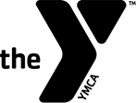
YMCA Youth Sports
Parent’s Code of Conduct

- Remain in the spectator area during competitions. Please do not come into the player area during games

- Let coaches coach.

- Keep comments positive to players, parents, officials, and coaches of their team.

- Please refrain from smoking or drinking alcoholic beverages at or prior to YMCA events.

- Cheer for your team.

- Show interest, enthusiasm, and support for your child.

- Be in control of your emotions.

- Help when you’re asked by a coach or an official.

- Thank the coaches, officials, and other volunteers who conduct the event.

