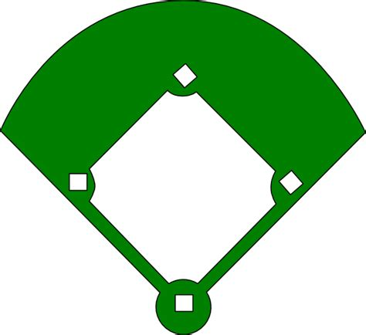**Youth Soccer Field Layout**

**U12 Field**

**U10 Field**

**U8 Field 2**

**U6 Field 2**

Parking Lot

North Y

**U6 Field** **1**

**U4 Field 2** 1

**U4 Field 1** 1

Dog Park

Outdoor Track

Outdoor Track

**U8 Field 1**

Outdoor Track