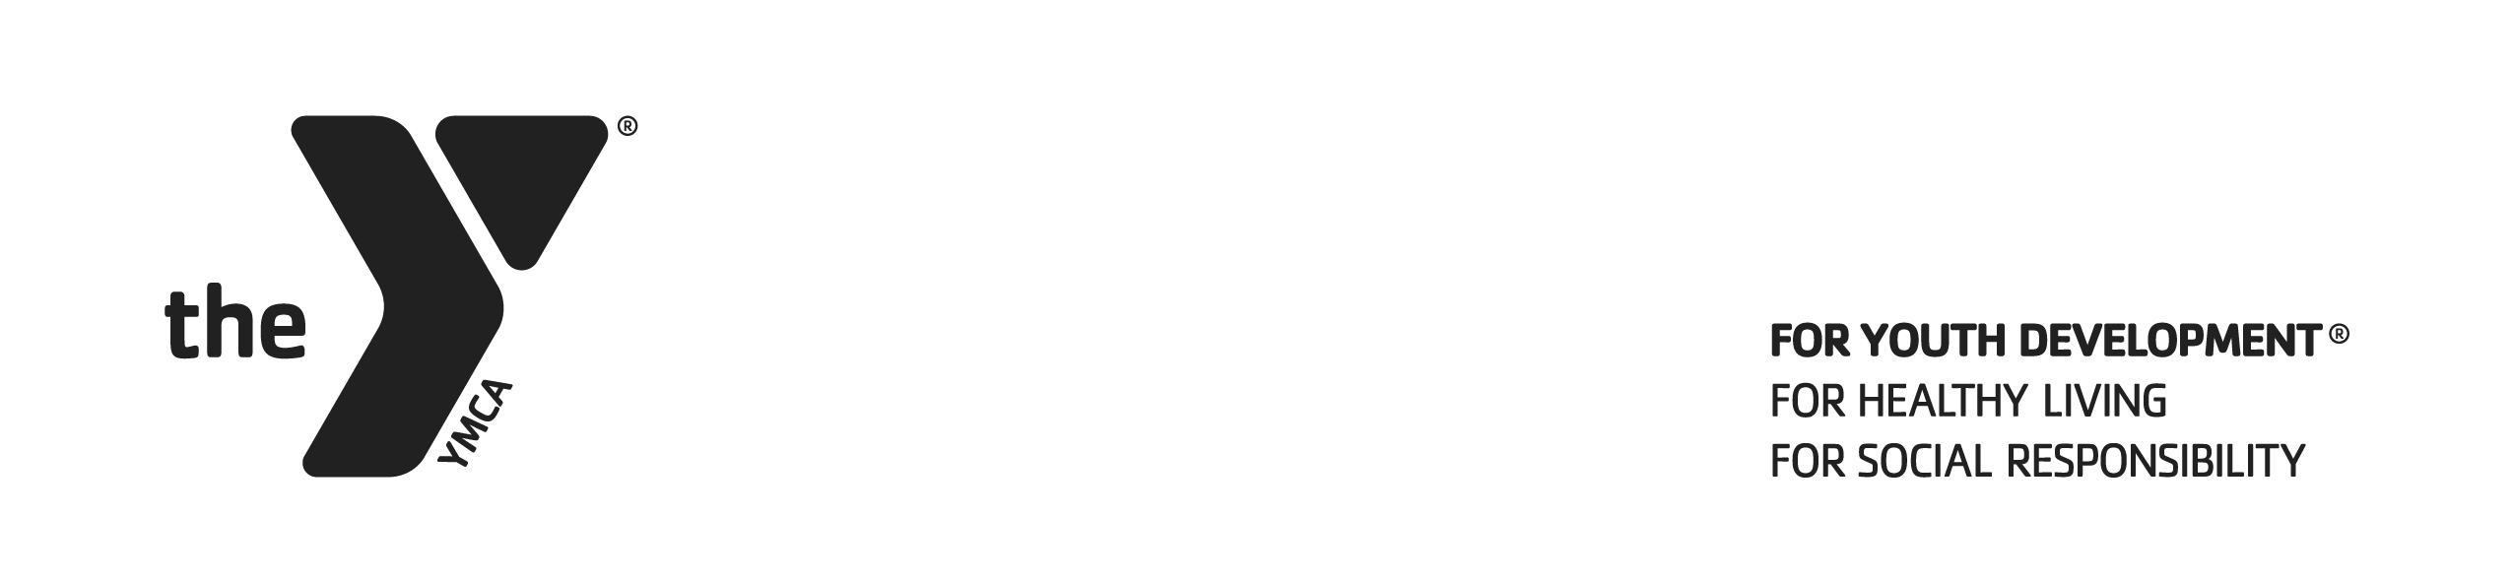

**HANOVER AREA YMCA**

**YOUTH VOLLEYBALL RULES**

**1. GAME PAY**

**To start game play the two coaches will do rock, paper, scissors. Winning coach gets to serve first. Team that serves first will start on side closest to the turf field/bathroom wall.**

**Grade 3/5 & 6/8 Beginner & Intermediate**

* 1. A circle rotation must be always done to ensure equal playing time for all players.
* After each set players MUST start within same rotation from where they left off at start of new set.
  1. Each team has one (1) thirty second timeout per set.
* After the timeout, teams MUST start at same position as when the timeout was called.
  1. If a player scores five consecutive points, the serving team keeps ball but a rotation must occur.
  2. **SERVING – If a player misses their first serve, they can serve the second designated line Once the ball goes over that player does not receive a second attempt on any missed serve.**
* **Grade 3/5 – First serve MUST occur from behind the red line. Second serve from blue line.**
* **Grade 6/8 – First serve MUST occur from behind the white line. Second serve from red line.**

**Grade 6/8 Advanced & High School**

* 1. Traditional subbing may occurand no limits on # of serves.
  2. No second attempt on a missed serve
  3. Each team has one (1) thirty second timeout per set.

**2. SCORING**

**2.1** Official score is kept for purposes of determining game end.

**2.2** A point is scored when the ball is grounded on the opponent’s side of the court, or when an opponent receives a fault.

**2.3** A set ends when one team has made 25 or 15 points depending on what # set teams are in. You must win by 2 points. First two sets will be 25 (cap 27) and 3rd set to 15 (cap 17). All three sets will always be played.

**3. PLAYING THE GAME**

**3.1** Game play is in rally format, with each serve counting as a point, and possession changing depending on which team faults.

**3.2** When the ball is “in play” it is in play from the moment it is served.

**3.3** The ball is “in” when it hits the ground inside the boundaries of the court. If coaches can’t agree then we will reply the point.

**3.5** The ball is “out” when: it hits the ground outside of the boundaries of the court, if it touches a person, object or the ceiling outside the court of play; if the ball touches the antenna, ropes, post or net outside the side bands; if it crosses the vertical plane of the net either partially or totally outside the crossing space, or if the ball crosses completely the lower space of the net. Players may go off-court to play a ball.

**3.6** Upon side-out, the serving team rotates one position.

**3.7 If the ball hits the ceiling/track/basketball hoop and stays on your side of net that team may play it (does not count as a hit extra hit). Once the ball goes over the net and hits the ceiling/track/basketball hoop it’s anex IMMEDIATE dead ball and balls goes to that team.**

**4. LEAGUE FAULTS – Advanced & High School ONLY**

**4.1** Faults will result in either a *point awarded to the opposing team and a side-out (change of possession), **replay the serve, or ***no point awarded, side-out.

**4.2 Definitions of Faults:**

BALL OUT: If the ball is hit by a player out-of-bounds.

FOUR HITS: If the ball is contacted four times before being hit over the net to the other team. Blocks are not considered a hit.

DOUBLE HIT: If one player contacts the ball twice before another player has contacted it.

ASSISTED HIT: If a player takes assistance from another player or any other object/structure in order to reach the ball.

ILLEGAL SERVE: If the ball is served into the net; a player touches the net on serve; the server takes more than 8 seconds to serve; the ball is tossed more than once in the air before being served,

ILLEGAL BLOCK OR SCREEN: If anyone on the serving team obstructs clear view of the server as the ball is being served, or if the defending team blocks a serve.

CROSSING THE CENTERLINE: If a player reaches or steps over or under the net or centerline. Follow-through from a spike is not considering crossing.

HELD/THROWN/LIFTED/CARRIED BALL: If a player executes an illegal contact including lifting, carrying or throwing the ball.

DOUBLE FAULT: If the ball is held simultaneously by two opposing players.

ROTATIONAL FAULT: On the serving team, if a serve is made without proper rotation of players to their positions

**5. SPORTSMANSHIP**

**5.1** Sanctions are given to players for rude or consistent misconduct, including actions contrary to good manners or expressing contempt, defamatory or insulting words or gestures, physical attack or intended aggression.

**5.2** A penalty is signaled by a yellow card for less severe offenses and results in an automatic loss of rally, point to opponent, and side-out.

**5.3** An expulsion is signaled by a red card for serious or repeated infractions and results in an automatic loss of rally, point to opponent, side-out and the offending player is required to sit in penalty area for the rest of the game.

**5.4** A disqualification is signaled by yellow and red cards together for repeated serious offenses and result in a player being dismissed from the playing area for the rest of the match and required to attend, but may not participate in the next scheduled match.

**5.5** Any verbally, physically, or mentally inappropriate behavior, speech or action may bring immediate dismissal from the program or site. **This includes bragging, bad language, cheating, intimidation, fighting, etc.**