Volleyball Rules
General Rules
- Matches will end after 50 minutes.
- It is mandatory to play two sets. If a team wins the first two sets, the game is over. A third set will be played if time permits and if neither team won both first two sets.
- There will be one 30 second timeout per team per set. Unused timeouts will not carry over to new sets.
- The first two sets will be played until one team scores 25 points. The third set will be played until one team scores 15 points.
  - U10 will play three timed sets of 8 minutes apiece.
- Teams must win by two points, with a cap of 30 points for the first two sets and 20 points for the third set.
- Rally scoring will be used for every game.
  - U10 will not use rally scoring
- 6 players will be on the court at any time, when possible. The minimum to start a game will be 5.
- Any part of the ball that contacts the line is considered “in.”
Serving
- All players must serve behind their designated service line.
- The server may not serve until the referee has blown the whistle.
- Overhand and underhand serves are allowed.
- Any serve that contacts the ceiling, net, or basketball backboard and does not go over is an automatic side out. Intentional serves at these objects will be considered a side out, as well.
- U0:
  - Service line will be marked with tape.
  - Server is permitted three (3) tosses. Contact must be made on or before the third toss.
  - After a server has scored three (3) consecutive points, the ball will automatically belong to the opposing team.
- U13:
  - Servers are allowed to use either the back line or the red line as a service point.
  - Server is permitted two (2) tosses. Contact must be made on or before the second toss.
  - After a server has scored five (5) consecutive points, the ball will automatically belong to the opposing team.
- U16:
  - Servers will use the back line as the service line.
  - Servers have 10 seconds to serve after the referee blows the whistle.
  - Server is allowed one (1) toss. If the serve is unsuccessful, control moves back to the other team.
Rallies
- Each team will have three (3) hits to return the ball.
- If the ball contacts the ceiling, post, or basketball backboard, it may still be played if the ball comes down on the same side as the team that created the contact, and the team has at least one remaining hit. If any contact occurs with ceiling/backboard/post and lands on receiving team’s side from the opposing team’s contact, the ball is considered dead, with the point awarded to the receiving team.
- Serves may not be blocked or spiked.
Rotations
- All teams must continuously rotate player positions to ensure participation.
- All players must enter the serving position.
- At the start of a new set, the rotation should continue from where the previous set finished.
- Rotation Pattern:
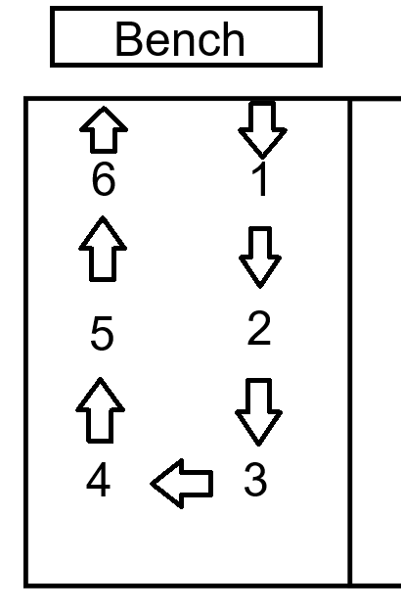
Violations
- Stepping over the service line on a serve.
  - Second chances may be given in U9 at referee discretion.
- Failure to serve over the net.
- Hitting the ball illegally (carrying, palming, throwing, etc.)
- Crossing under the net line
- Touching/contacting any part of the net
- The ball contacting the net antenna OR entering the opponent’s side from outside of the net antenna
Referees
- The referee shall be the sole judge on the field of play.
- The referee can ask coaches, parents, players, and spectators to leave the field of play or the facilities to maintain a pleasant atmosphere and control of the game.
- If a coach, player, or spectator is ejected from the game, that person is automatically removed from the next game and will be reviewed by the Sports Director and Executive Director. Should another incident occur in the same season, the coach, player, or spectator may be removed from the league permanently.
- The referee may stop, suspend, or terminate the game because of interference.
Team Responsibilities
- Each team is required to provide a line judge. These line judges may consist of parent volunteers or assistant coaches.
- Both teams are responsible for cleaning up their bench space immediately after the game.
- During the game, there will be a limit of two (2) coaches on the sideline. Only one coach will be permitted to stand at one time.
- All spectators must be seated on the sideline and cannot stand or sit on the court.
- Coaches must stay on their sideline/bench area only.

